# Setup

* Navigate to <https://www.mathworks.com/products/compiler/matlab-runtime.html> and download the MATLAB Runtime Installer for R2019b under the Windows Column, and then install it.

|  |
| --- |
|  |

* Navigate to <https://www.anaconda.com/distribution/#download-section> and download the most recent version of Anaconda, Python 3.7 version, 64-bit Graphical Installer, and then install it.

|  |
| --- |
|  |

* Download the Casting Geometric Toolsuite (CGT) from your industry organization and unzip the folder somewhere on your computer.

# Basic Usage

* Open a new file explorer window in Windows.
* Navigate to the unzipped folder.
* Type “cmd” in the file navigation bar to open a command window in that folder.
* Type “CGT.exe -h” to see more information on usage of the application.
* Type “CGT.exe <path\to\settings\file> -ap” to analyze an STL file and view the results.
* Type “CGT.exe <path\to\settings\file> -a” to analyze an STL file.
* Type “CGT.exe <path\to\settings\file> -p” to view the results of a previous analysis without analyzing again.
* To analyze your own geometries, copy the appropriate settings file template provided under the “res” folder to a new location.
* Open the file in a text editor and find “processes” -> “Casting” -> “input_file”. Put the absolute path to the STL file between the quotes after the colon. See below for an example.

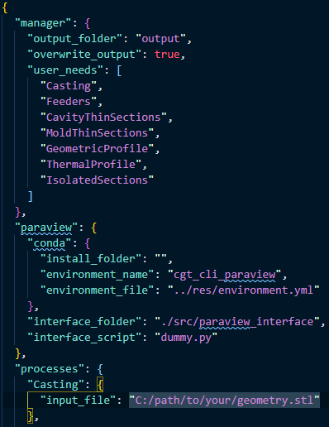

# ParaView Usage

* More information on ParaView usage forthcoming.

# Analysis Method Descriptions

* More information on Analysis methods forthcoming.

# Advanced Usage and Options

* More information on options forthcoming.